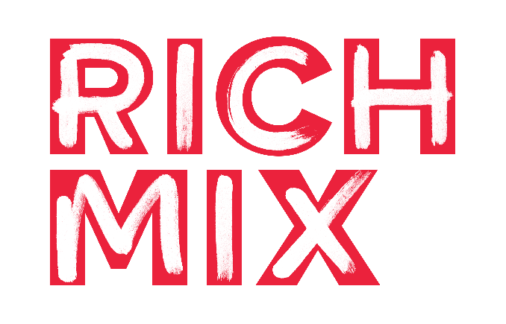

Application Form

Position applied for: Duty Manager

PERSONAL DETAILS
Surname | Other names | Title & personal pronoun (optional)
Address | Contact details:  Home tel:  Mobile:  Email:

RELEVANT QUALIFICATIONS & TRAINING
Starting with the most recent, please give details of any qualifications and training that are relevant to the role for which you are applying.
Name of awarding body, institution or provider | Dates  From - To |  | Qualification gained

EMPLOYMENT HISTORY
Please give details of your employment history, starting with your most recent position, including relevant voluntary work and work experience.
Job title  and  Employer (Name of organisation) | Dates in Employment  From - To (indicate if current) | Key Responsibilities  (and for your most recent position only, please include your pay rate) | Reason for leaving  (if applicable)

PERSONAL STATEMENT
With reference to the Person Specification section of the Job Description, please highlight how your experience meets the ‘Desirable skills, knowledge and experience’ requirements of this role. Please use a maximum of 500 words (1 A4 sized page).

ADDITIONAL INFORMATION
Please give details of any other information which might be relevant to this application that has not already been included above. Please use a maximum of 200 words (½ A4 sized page).

RIGHT TO WORK
Please delete YES or NO as appropriate. If your answer is yes, please provide further details.

Please be aware that if offered employment, you will be required to show an original document(s) as proof of your right to work in the UK.
Are you aware of any reason why you would not be able to work in the United Kingdom?
YES NO
If YES, please provide more information (this is optional)

Do you require a work permit or permission to work in the United Kingdom? YES NO
If yes, do you have original valid documents? YES NO
If applicable, please confirm expiry dates of documents:

Are you subject to any conditions relating to your employment in the United Kingdom?
YES NO

GENERAL
Please delete YES or NO as appropriate.
Are you able to attend an interview on week commencing 4 July 2022? YES NO
Preferred dates/times:
If you are invited to an interview, do you have any access requirements? If your answer is yes, please provide further details.
YES NO
Further details:
REFEREES
Please give details of two referees, one of whom must be your present or most recent employer or course tutor if you are currently a student. The referee should know you in a work capacity. Referees should not include relatives.
Name | Name
Job Title, Name of Organisation | Job Title, Name of Organisation
City, country in which they work | City, country in which they work
Telephone Number | Telephone Number
Email Address | Email Address
In what context does this referee know you? | In what context does this referee know you?
Do we have permission to contact this referee if you receive a conditional offer of employment? | Do we have permission to contact this referee if you receive a conditional offer of employment?

GENERAL MONITORING
Where did you hear about this vacancy?

DECLARATION:
By printing my name below, I confirm that the information I have given in this application for employment is accurate and complete and that it may form the basis of a contract of employment with Rich Mix.
I understand that failure to disclose any relevant information or the provision of false information will nullify any subsequent contract of employment.
I consent to Rich Mix processing the data on this form, and (if applicable) subsequent data collected during the administration of my term of employment in line with the requirements of the UK Data Protection Act 2018.
Full Name:
Date:

Please return this completed form along with an Equal Opportunities Monitoring Form by 24 Jun 2022 at 12pm to recruitment@richmix.org.uk.
Please ensure you include ‘[Your first name] [Your surname] Application: Duty Manager’ in your email subject line.
Please include your name in the filename of your attachments and ensure that your attached files are in PDF or Word format.
A covering letter, CV, or other material is not required and will not be reviewed.
Please note that Equal Opportunities Monitoring forms are not shared with the hiring panel.
If you would like this form in a different format, please contact recruitment@richmix.org.uk.

